Technical Questions For London Assessment Centre

- We're looking for people with a real passion for collaboratively creating great software. Please give an example of a software component you have designed and written from concept to deployment, outlining the steps you took. (1000 character limit)

Audition Management System is an online process management solution to Drama, Dance and Performing Arts institutions or academies to manage their audition applications and process. This is the first system available to a niche marketplace. The application until now has been either paper based or simple RS forms through the website. This system covers the entire audition process from initial application, through the audition process where they are marked by examiners, through recall auditions, outcomes and taking payment of fees. It also manages setting up of audition days and additional outreach venues to expand the potential intake of each school.

The current version of the AMS is more generic and it is design and built to suit to most of the business requirements. Previous two versions were custom builds and those were designed bespoke to meet specific business. While working on the similar systems for two different businesses, I realized that this system can be designed more customizable and make it more generic. Now this product has been one of the company's flagship products at the Considerthis UK.

- Using the example that you provided above, tell us about a significant decision you made to solve a technical challenge. Give details of technologies that you chose and why you chose them. (1000 character limit)

It is always a challenge in software development that to build a single solution to all businesses. In the case of Audition management system I figured that out the core processes of audition application and audition management is very much same in many performing arts school and colleges but the only differences is in the information hierarchy and some particular business logic. There may be other alternative ways to maximize the common requirements of all schools and colleges in one solution but the one I implemented is Dynamic System Development Methodology, in which I encapsulate modules and components based on functionality and domains. This helps me to collaborate the requirements that is baseline at a high-level, increases the agility in incremental development to adapt the reversible changes. AMS is database driven software, designing smart database architecture is more important and it is the most challenging job to database that will allow system to have dynamic customizable features and functionality.

ASM now provides more customizable features form admin user level, enabled business intelligence.

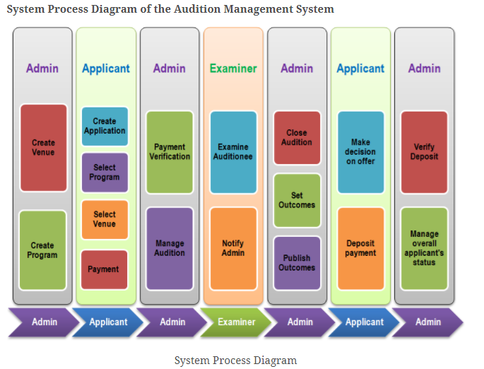
Figure 1: System Process Diagram of AMS
- Using the example that you provided above, tell us about how you ensured your software was fit for purpose and of high quality. What did you learn and what would you do differently next time to do a better job? (1000 character limit).

AMS development and deployment has been through different stages. AMS previous two versions were implemented and live to its users. The features, functionality the enhancement on solution are actual the feedback from its real users from all sides, business and users. These feedbacks have as many roles in user experience as it has it has in the features and functionality. Software is fit to the purpose because there are already businesses using it and getting a lot of support for their business by using the system. There may be many different aspects of measuring the software quality; in term of ASM it manages its label to the high quality because of its performance ability and user satisfaction. This system manages user personal information so AMS ensures the security. The purpose of the system is to increase connection and communication between its business and their applicants which it has been helping and provides more business intelligence and enable business to reach out to their applicants.

One thing that I have learnt, the adaptability is the key in software development. The idea that adaptability might itself be an evolved characteristic is a relatively new concept. It has become the key characteristic of well-designed applications because modern software systems are expected to service rapidly changing business environments efficiently and with robust reliability over a time span of decades. If a system is not designed with this sort of adaptation in mind, it can only degrade to chaos in the face of ever-changing requirements. From which I will do next time to pay attention both to broad engineering strategies and to the details of implementation.

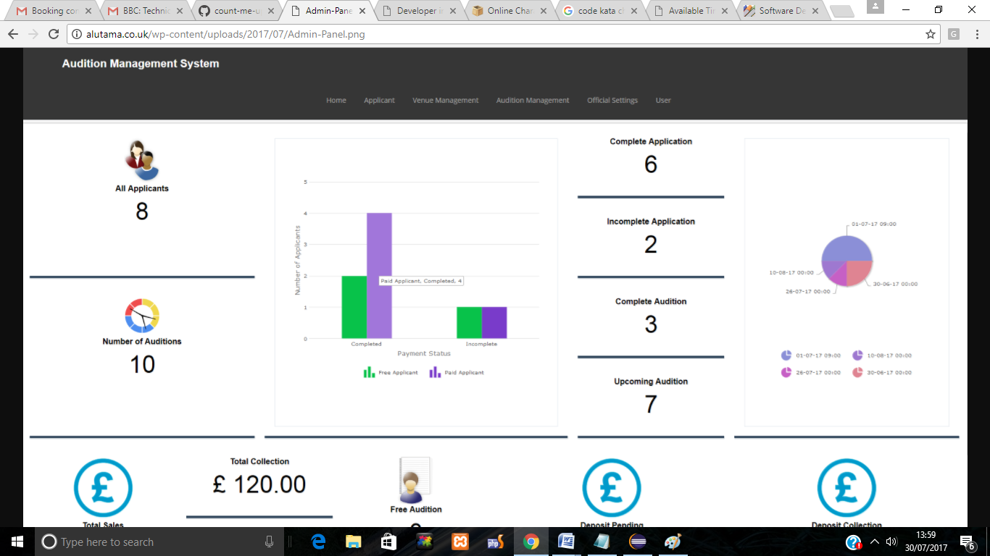
Figure 2: AMS admin Dashboard

- Please confirm the language used to complete the code kata challenge?

I have used SCALA to complete the count me up assignment. There are 3 classes
- candidate
- voter
- countmeup
countmeup has a main function.
I have used JDBC to connect with MySQL data.

There are 3 tables and 2 views

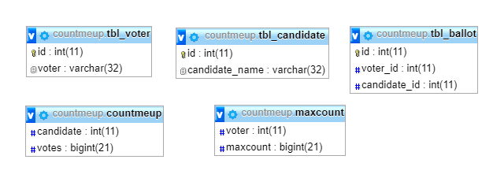
Figure 3: Database schema

maxcount keeps how many times the voter votes
countmeup keeps the counter of total votes of the candidate from the ballot
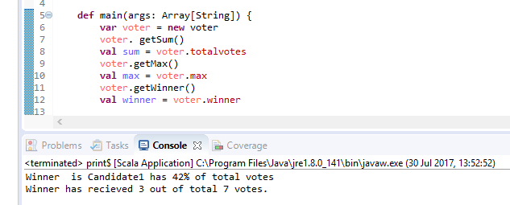
Figure 4: Final Result of Vote counts
Data in ballot
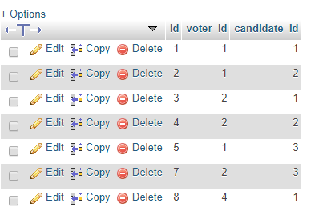
Figure 5: Data in ballot.
Draw-Back of this Design or implemetation
- Candidate cannot be contender for another program. There must be another 2 objects or tables in the database for Program and Program_Candidate, and table ballot field candidate id should be removed and new field program_candidate_id field must be added. This will allow voter to take participate in many program and vote to many candidate. Although the rules for Max vote 3 can still be applied.
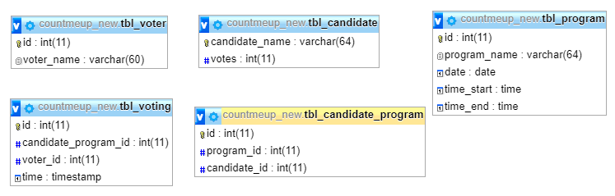
Figure 6: New Database class diagram
- If there are more than 1 candidate receive the same maximum vote counts code will not show both of them since the function is not applied yet.

